**Prerequisites:**

Start qbymsqvdc001-VM as root and ping test

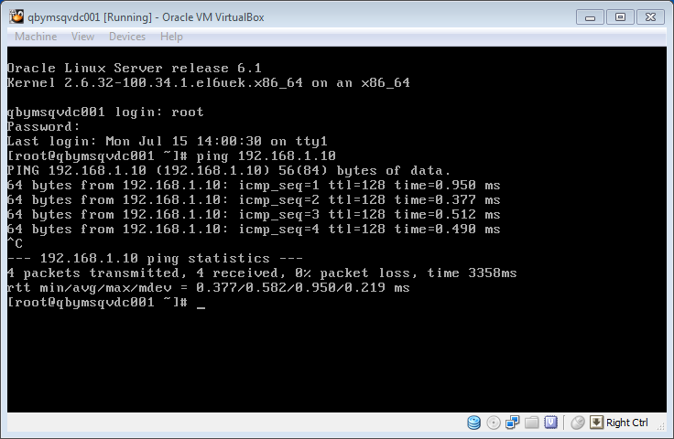

Start Oracle Linux as oracle user and ping VM

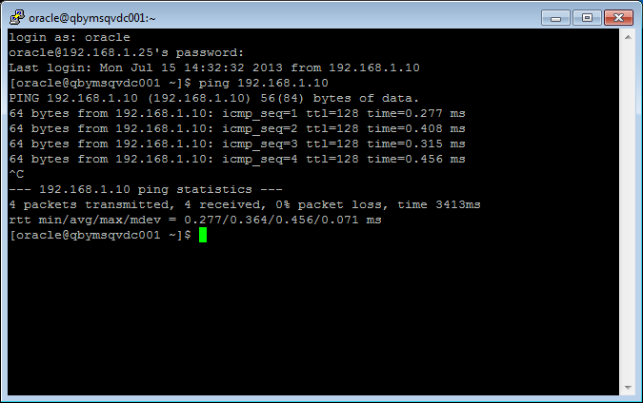

Start sqlplus as sysdba

*sqlplus / as sysdba*

*startup mount*

*alter database open;*

*select * from dual;*

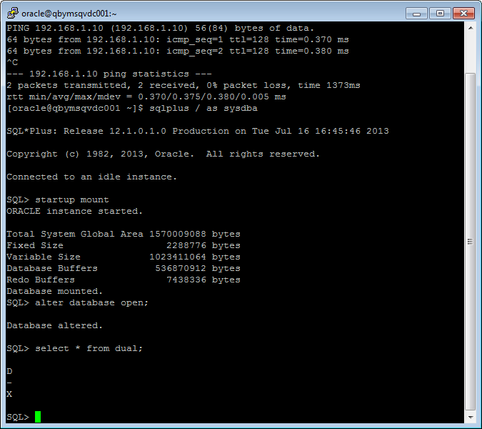

Create new user:

*create user kanstantsin_arzhakhouski identified by 123456 default tablespace tbs_lab;*

Grant Connect Role and Resource Role:

*grant connect to kanstantsin_arzhakhouski;*

*grant resource to kanstantsin_arzhakhouski;*

*grant select on scott.dept to kanstantsin_arzhakhouski;*

*grant select on scott.emp to kanstantsin_arzhakhouski;*

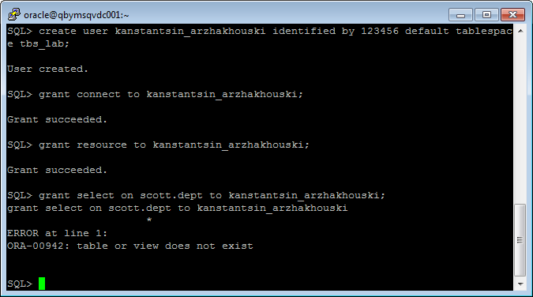

Connection to sqlplus as Kanstantsin_arzhakhouski

*sqlplus kanstantsin_arzhakhouski/123456*

*select uid from dual;*

*select user from dual;*

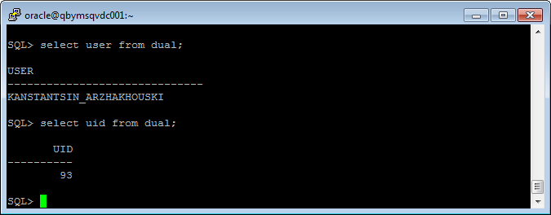

*create table t*

*( a int,*

*b varchar2(4000) default rpad('*',4000,'*'),*

*c varchar2(3000) default rpad('*',3000,'*')*

*)*

*/*

*insert into t (a) values ( 1); --* ***ERROR***

*ALTER USER kanstantsin_arzhakhouski QUOTA 500M ON tbs_lab;*

*insert into t (a) values ( 1);*

*insert into t (a) values ( 2);*

*insert into t (a) values ( 3);*

*commit;*

*select * from t;*

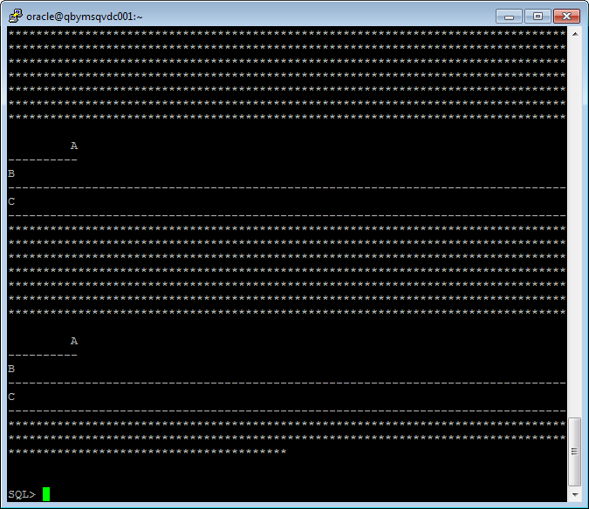

*delete from t where a = 2 ;*

*commit;*

*insert into t (a) values ( 4);*

*commit;*

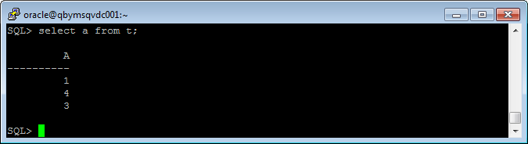

**Understanding Low level of data abstraction: Heap Table Segments**

*drop table t;*

*Create table t ( x int primary key, y clob, z blob );*

*select segment_name, segment_type from user_segments;*

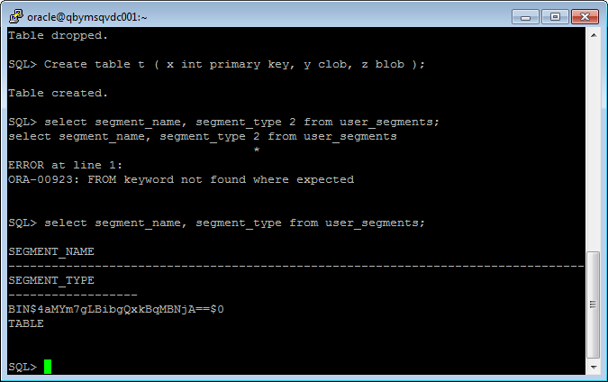

*Create table t*

*( x int primary key,*

*y clob,*

*z blob )*

*SEGMENT CREATION IMMEDIATE*

*/*

*select segment_name, segment_type from user_segments;*

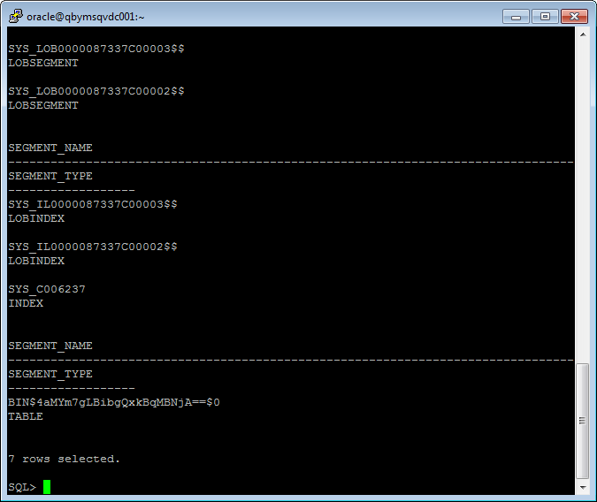

*SELECT DBMS_METADATA.GET_DDL('TABLE','T') FROM dual;*

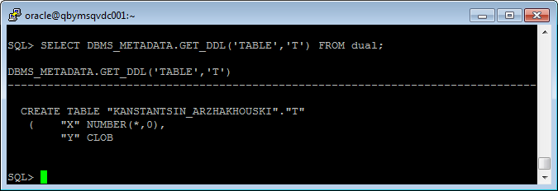

**Index Organized Tab**

*CREATE TABLE emp AS*

*SELECT*

*object_id empno*

*, object_name ename*

*, created hiredate*

*, owner job*

*FROM*

*all_objects*

*/*

*alter table emp add constraint emp_pk primary key(empno);*

*begin*

*dbms_stats.gather_table_stats( user, 'EMP', cascade=>true );*

*end;*

*/*

*CREATE TABLE heap_addresses*

*(*

*empno REFERENCES emp(empno) ON DELETE CASCADE*

*, addr_type VARCHAR2(10)*

*, street VARCHAR2(20)*

*, city VARCHAR2(20)*

*, state VARCHAR2(2)*

*, zip NUMBER*

*, PRIMARY KEY (empno,addr_type)*

*)*

*/*

*CREATE TABLE iot_addresses*

*(*

*empno REFERENCES emp(empno) ON DELETE CASCADE*

*, addr_type VARCHAR2(10)*

*, street VARCHAR2(20)*

*, city VARCHAR2(20)*

*, state VARCHAR2(2)*

*, zip NUMBER*

*, PRIMARY KEY (empno,addr_type)*

*)*

*ORGANIZATION INDEX*

*/*

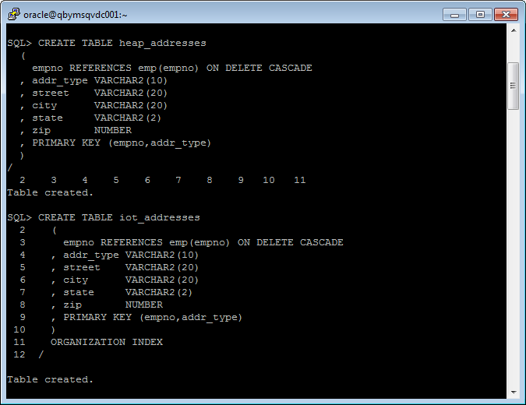

*INSERT INTO heap_addresses*

*SELECT empno, 'WORK' , '123 main street' , 'Washington' , 'DC' , 20123 FROM emp;*

*INSERT INTO iot_addresses*

*SELECT empno , 'WORK' , '123 main street' , 'Washington' , 'DC' , 20123 FROM emp;*

*INSERT INTO heap_addresses*

*SELECT empno, 'HOME' , '123 main street' , 'Washington' , 'DC' , 20123 FROM emp;*

*INSERT INTO iot_addresses*

*SELECT empno, 'HOME' , '123 main street' , 'Washington' , 'DC' , 20123 FROM emp;*

*INSERT INTO heap_addresses*

*SELECT empno, 'PREV' , '123 main street' , 'Washington' , 'DC' , 20123 FROM emp;*

*INSERT INTO iot_addresses*

*SELECT empno, 'PREV' , '123 main street' , 'Washington' , 'DC' , 20123 FROM emp;*

*INSERT INTO heap_addresses*

*SELECT empno, 'SCHOOL' , '123 main street' , 'Washington' , 'DC' , 20123 FROM emp;*

*INSERT INTO iot_addresses*

*SELECT empno, 'SCHOOL' , '123 main street' , 'Washington' , 'DC' , 20123 FROM emp;*

*Commit;*

Get statistics

*exec dbms_stats.gather_table_stats( 'kanstantsin_arzhakhouski', 'HEAP_ADDRESSES' );*

*exec dbms_stats.gather_table_stats( 'kanstantsin_arzhakhouski', 'IOT_ADDRESSES' );*

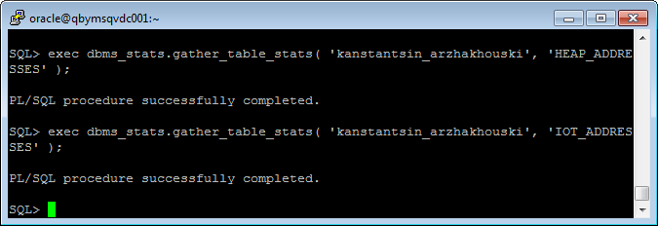

SET AUTOTRACE ON EXPLAIN

*SELECT \**

*FROM emp ,*

*heap_addresses*

*WHERE emp.empno = heap_addresses.empno*

*AND emp.empno = 42;*

*SELECT \**

*FROM emp ,*

*iot_addresses*

*WHERE emp.empno = iot_addresses.empno*

*AND emp.empno = 42;*

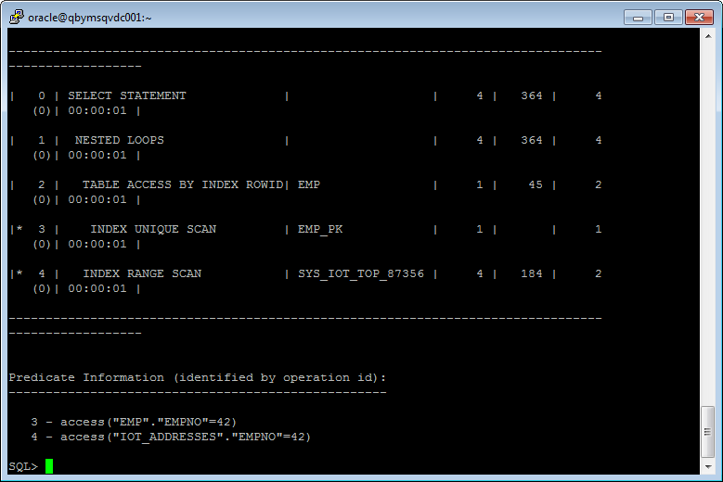

Expected Heap table cost > IOT table cost

Index Clustered Tables

The only difference from a normal table is that we used the CLUSTER keyword and told database which column of the base table will map to the cluster key in the cluster itself.

*CREATE cluster emp_dept_cluster( deptno NUMBER( 2 ) )*

*SIZE 1024*

*STORAGE( INITIAL 100K NEXT 50K );*

*CREATE INDEX idxcl_emp_dept on cluster emp_dept_cluster;*

*CREATE TABLE dept*

*(*

*deptno NUMBER( 2 ) PRIMARY KEY*

*, dname VARCHAR2( 14 )*

*, loc VARCHAR2( 13 )*

*)*

*cluster emp_dept_cluster ( deptno ) ;*

*CREATE TABLE emp*

*(*

*empno NUMBER PRIMARY KEY*

*, ename VARCHAR2( 10 )*

*, job VARCHAR2( 9 )*

*, mgr NUMBER*

*, hiredate DATE*

*, sal NUMBER*

*, comm NUMBER*

*, deptno NUMBER( 2 ) REFERENCES dept( deptno )*

*)*

*cluster emp_dept_cluster ( deptno ) ;*

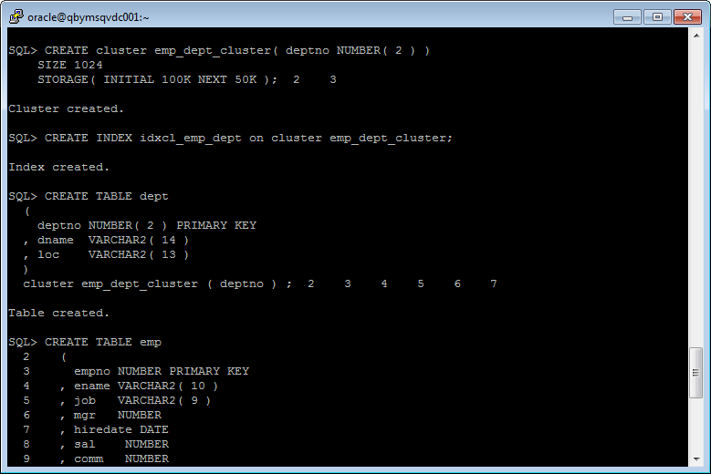

*INSERT INTO DEPT VALUES (10, 'ACCOUNTING', 'NEW YORK');*

*INSERT INTO DEPT VALUES (20, 'RESEARCH', 'DALLAS');*

*INSERT INTO DEPT VALUES (30, 'SALES', 'CHICAGO');*

*INSERT INTO DEPT VALUES (40, 'OPERATIONS', 'BOSTON');*

*commit;*

*INSERT INTO EMP VALUES*

*(7369, 'SMITH', 'CLERK', 7902,*

*TO_DATE('17-DEC-1980', 'DD-MON-YYYY'), 800, NULL, 20);*

*INSERT INTO EMP VALUES*

*(7499, 'ALLEN', 'SALESMAN', 7698,*

*TO_DATE('20-FEB-1981', 'DD-MON-YYYY'), 1600, 300, 30);*

*INSERT INTO EMP VALUES*

*(7521, 'WARD', 'SALESMAN', 7698,*

*TO_DATE('22-FEB-1981', 'DD-MON-YYYY'), 1250, 500, 30);*

*INSERT INTO EMP VALUES*

*(7566, 'JONES', 'MANAGER', 7839,*

*TO_DATE('2-APR-1981', 'DD-MON-YYYY'), 2975, NULL, 20);*

*INSERT INTO EMP VALUES*

*(7654, 'MARTIN', 'SALESMAN', 7698,*

*TO_DATE('28-SEP-1981', 'DD-MON-YYYY'), 1250, 1400, 30);*

*INSERT INTO EMP VALUES*

*(7698, 'BLAKE', 'MANAGER', 7839,*

*TO_DATE('1-MAY-1981', 'DD-MON-YYYY'), 2850, NULL, 30);*

*INSERT INTO EMP VALUES*

*(7782, 'CLARK', 'MANAGER', 7839,*

*TO_DATE('9-JUN-1981', 'DD-MON-YYYY'), 2450, NULL, 10);*

*INSERT INTO EMP VALUES*

*(7788, 'SCOTT', 'ANALYST', 7566,*

*TO_DATE('09-DEC-1982', 'DD-MON-YYYY'), 3000, NULL, 20);*

*INSERT INTO EMP VALUES*

*(7839, 'KING', 'PRESIDENT', NULL,*

*TO_DATE('17-NOV-1981', 'DD-MON-YYYY'), 5000, NULL, 10);*

*INSERT INTO EMP VALUES*

*(7844, 'TURNER', 'SALESMAN', 7698,*

*TO_DATE('8-SEP-1981', 'DD-MON-YYYY'), 1500, 0, 30);*

*INSERT INTO EMP VALUES*

*(7876, 'ADAMS', 'CLERK', 7788,*

*TO_DATE('12-JAN-1983', 'DD-MON-YYYY'), 1100, NULL, 20);*

*INSERT INTO EMP VALUES*

*(7900, 'JAMES', 'CLERK', 7698,*

*TO_DATE('3-DEC-1981', 'DD-MON-YYYY'), 950, NULL, 30);*

*INSERT INTO EMP VALUES*

*(7902, 'FORD', 'ANALYST', 7566,*

*TO_DATE('3-DEC-1981', 'DD-MON-YYYY'), 3000, NULL, 20);*

*INSERT INTO EMP VALUES*

*(7934, 'MILLER', 'CLERK', 7782,*

*TO_DATE('23-JAN-1982', 'DD-MON-YYYY'), 1300, NULL, 10);*

*COMMIT;*

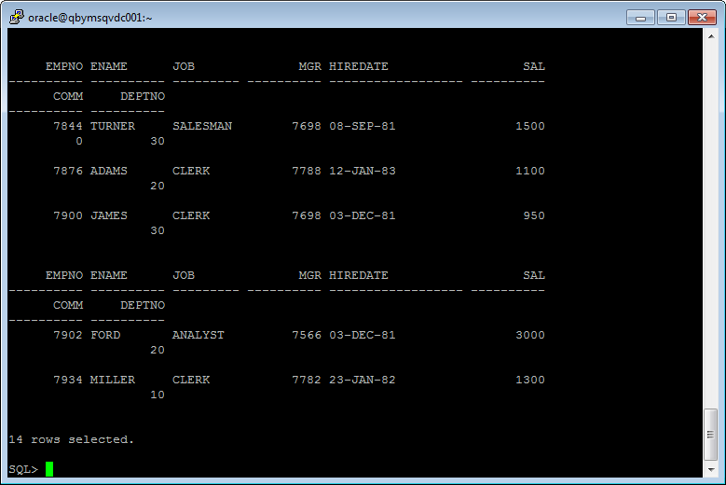

All data in one block

*SELECT \**

*FROM*

*(*

*SELECT dept_blk, emp_blk, CASE WHEN dept_blk <> emp_blk THEN '*' END flag, deptno*

*FROM*

*(*

*SELECT dbms_rowid.rowid_block_number( dept.rowid ) dept_blk, dbms_rowid.rowid_block_number( emp.rowid ) emp_blk, dept.deptno*

*FROM emp , dept*

*WHERE emp.deptno = dept.deptno*

*)*

*)*

*ORDER BY deptno;*

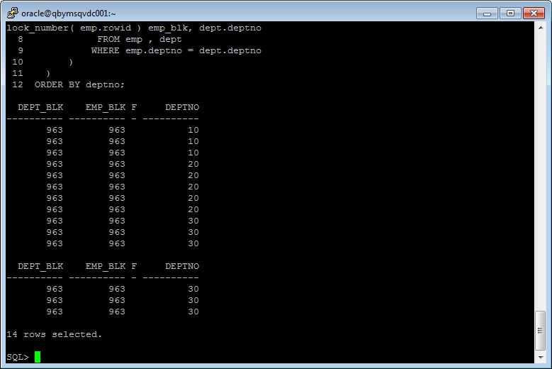

# Hash Clustered Tables

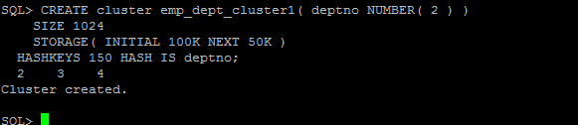

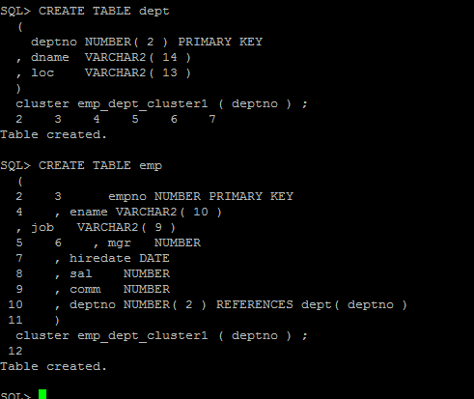

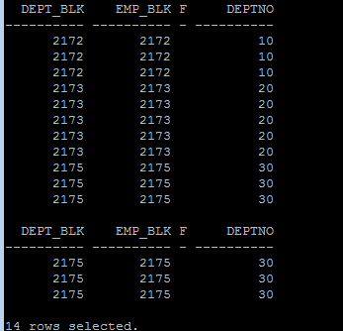

The cluster key index is replaced with a hash function. Oracle will take the key value for a row, hash it using either an internal function or one you supply, and use that to figure out where the data should be on disk.